-------------------------------------

**Software Requirements Specification**

For

**PT and Customer Support System**

Version 1.0 approved

Prepared by **Group 2**

Process Impact

May 8, 2022

**Table of Contents**

Revision History............................................................................................................................. ii

1. Introduction........................................................................................................................ 1

1.1 Purpose............................................................................................................................... 1

1.2 Document Conventions...................................................................................................... 1

1.3 Project Scope and Product Features................................................................................... 1

1.4 References.......................................................................................................................... 1

2. Overall Description............................................................................................................ 1

2.1 Product Perspective............................................................................................................ 1

2.2 User Classes and Characteristics........................................................................................ 2

2.3 Operating Environment...................................................................................................... 3

2.4 Design and Implementation Constraints............................................................................. 3

2.5 Assumptions and Dependencies.......................................................................................... 3

3. System Features................................................................................................................... 3

3.1 Order Meals from Cafeteria................................................................................................ 3

3.1.1 Description.......................................................................................................................... 3

3.1.2 Functional Requirements..................................................................................................... 3

3.2 Order Meals from Restaurants............................................................................................ 5

3.3 Create, View, Modify, and Delete Meal Subscriptions....................................................... 5

3.4 Create, View, Modify, and Delete Cafeteria Menus........................................................... 5

4. Data Requirements............................................................................................................. 6

4.1 Logical Data Model............................................................................................................ 6

4.2 Data Dictionary................................................................................................................... 6

4.3 Reports................................................................................................................................ 9

4.3.1 Ordered Meal History Report............................................................................................. 9

4.4 Data Integrity, Retention, and Disposal.............................................................................. 9

5. External Interface Requirements....................................................................................... 10

5.1 User Interfaces.................................................................................................................. 10

5.2 Software Interfaces........................................................................................................... 10

5.3 Hardware Interfaces.......................................................................................................... 10

5.4 Communications Interfaces............................................................................................... 10

6. Quality Attributes.............................................................................................................. 11

6.1 Usability Requirements..................................................................................................... 11

6.2 Performance Requirements............................................................................................... 11

6.3 Security Requirements...................................................................................................... 11

6.4 Safety Requirements......................................................................................................... 11

6.5 Availability Requirements................................................................................................ 11

6.6 Robustness Requirements................................................................................................. 11

Appendix A: Analysis Models....................................................................................................... 12

**Revision History**

| **Name** | **Date** | **Reason For Changes** | **Version** |
| --- | --- | --- | --- |
| Nguyen Hoang Viet | 2/7/22 | initial draft: added **“1.Introduction”** | 1.0 draft 1 |
| Hải Đăng,Hoàng Việt | 3/7/22 | Completed **“2. Overall Description”** | 1.0 draft 2 |
| Đông My, Phú Sơn | 4/7/22 | Completed **3.1 to 3.3** | 1.0 draft 3 |
| Đông My, Phú Sơn | 5/7/22 | Completed **3.4 to 3.6** | 1.0 draft 4 |
| Đăng Khoa | 6/7/22 | Completed **‘4. Data Requirements**’ | 1.0 draft 5 |
| Hải Đăng,Hoàng Việt | 7/7/22 | Completed **5.External Interface Requirements** | 1.0 draft 6 |
| Đông My, Phú Sơn | 9/7/22 | Completed **6.Quality Attributes** | 1.0 draft 7 |

# 

# **1.** **Introduction**

## **1.1** **Purpose**

This SRS describes the functional and non-functional requirements for software release 1.0 of the PT and Customer Support System (PTCSS). This document is intended to be used by the members of the project team who will implement and verify the correct functioning of the system. Unless otherwise noted, all requirements specified here are committed for release 1.0.

## **1.2** **Document Conventions**

No special typographical conventions are used in this SRS.

## **1.3** **Project Scope and Product Features**

The PTCSS will permit PTs to make a complete meal and workout schedule for customers and let admins easily manage the PT-customer list and monthly announcements. Customers can see their weekly schedule on their smartphones. A detailed description is available in the *PT and Customer Support System Vision and Scope Document*[1]*,* along with the features that are scheduled for full or partial implementation in this release.

## **1.4** **References**

*PT and Customer Support System Vision and Scope Document*[1]

# **2.** **Overall Description**

## **2.1** **Product Perspective**

The Personal Trainer and Customer Support System is a mobile-based application that is aimed at helping and improving communication between PTs and their respective customers. The app will allow PTs to set up a weekly workout schedule for gym users as well as to create an appropriate recommended menu for the client. As a result, the PTs are expected to be able to take on more customers at a time and increase efficiency in scheduling exercises.

## **2.2** **User Classes and Characteristics**

## 

| **Gym users/Customers** | These are customers of the gyms that will be using the application. They are managed by a Personal Trainer who will give them workout instructions and recommend a menu or diet that they should follow. |
| --- | --- |
| **Personal Trainers** | The Personal Trainers are in charge of training the gym users. They are responsible for setting up a weekly schedule for their trainees as well as recommending a menu that is suitable for their workout regimen. They will need to be trained to understand how to use the features of the app. |
| **Manager/Administrator** | The manager can access a list of Personal Trainers and their customers. The manager is also responsible for sending notifications regarding any changes to or news about the gym. |

## **2.3** **Operating Environment**

The PT and Customer Support System is a mobile application that shall be compatible with some standard mobile operating systems. Supported OS are Android version 12 or lower and IOS version 15.5 or lower.

## **2.4** **Design and Implementation Constraints**

**CO-1**: The system shall use the current corporate standard Mongo database engine.

**CO-2**: The system shall use java to maintain the code in the android environment .

## **2.5** **Assumptions and Dependencies**

**DE-1**: The body index reports depend on the machine that the gym uses to measure the customer's body.

# **3.** **System Features**

**3.1 Create, View, Modify, and Delete weekly menus:**

**1. Description**

Personal trainers with verified personal accounts can create, view, modify, and delete clients' weekly menus to match their diet, fitness and health improvement.

**2. Functional Requirements**

| **Weekly menu.Create: Create a menu for the week's meals** | |
| --- | --- |
| .Login: | the system will confirm PT's personal account to log in. |
| .Remind: | The system will remind PT about the days of the week with the menu available. |
| .Perform: | PT will choose each day of the week to create the menu. Choose ingredients for each meal including food ingredients, quantity for each food suitable for each meal. |
| .Submit | PT will submit the added meals and display them to PT and Customer's system. |
| **Weekly menu.Edit: View and edit menu** | |
| .Display: | The system will display the menu every day of the week that PT has created for the customer. |
| .Review: | PT will check the menu of meals that have been made for customers. |
| .Success: | PT will update the menu for customers to follow and follow. |
| .Fail: | PT will correct the meals of the menu that are not reasonable. Then will update the menu to the system. |
| .Delete: | PT will delete the menu when it feels that it is no longer suitable for the customer's mode. |
| **Weekly menu.Response: Modify menu dependent on customer's comment** | |
| .Display: | The system will display customer feedback about the menu. |
| .OK: | PT will modify the menu to suit the customer's diet. |
| .No: | PT will explain to the client about the menu diet. |
| .ModifyMenu: | PT will select editable meals. Then choose the right meal ingredients according to the customer's wishes. Adjust the quantity to suit the diet and food composition. |

**3.2 Create, View, Modify, and Delete weekly workout exercises:**

**1. Description**

Personal trainers with a verified personal account can create, view, modify, and delete workouts and workout content tailored to each client's regimen.

**2. Functional Requirements**

| **Workout exercises.Create: Create exercises for the week's workouts.** | |
| --- | --- |
| .Login: | the system will confirm PT's personal account to log in. |
| .No: | If PT does not have a personal account, the system will provide options for PT to register immediately and create a menu. Then create workout exercises for each day of the week for the client. |
| .Remind: | The system will remind PT about the days of the week that are available for workout exercises. |
| .Perform: | PT will choose each day of the week to create workout exercises. Select workout exercises for clients including training time, regular health check and workout exercises appropriate to each client's improvement stage. |
| .Submit | PT will submit the added workout exercises and display them on PT and Client's system. |
| **workout exercises.Edit: View and edit workout exercises** | |
| .Display: | The system will display workout exercises all days of the week that PT has created for customers. |
| .Review: | PT will check each day's workout exercises for the client. |
| .Success: | PT will update workout exercises for customers to follow and follow. |
| .Fail: | The PT will correct the incorrect workout exercises. After that, workout exercises will be updated on the system. |
| .Delete: | PT will delete workout exercises when it feels no longer suitable for the client's exercise regimen. |
| **Workout exercises.Response: Modify workout exercises dependent on customer's comment** | |
| .Display: | The system will display customer feedback about the workout exercises. |
| .OK: | PT will correct workout exercises in accordance with the client's training regimen and process of improving health and body. |
| .No: | PT will explain to the client about the exercises that are suitable for the client's regimen and body situation. |
| .ModifyMenu: | PT will select workout exercises that can be edited. Then choose the right workout exercises according to the client's wishes while ensuring improvement. Edit training time in accordance with the client's regimen and exercises. |

**3.3 Record customer’s monthly measurements**

**1. Description**

A gym’s PTs whose identity has been verified may enter measurements of their customers to follow the productivity and performance of their training process and make changes in process if theses numbers has not met target’s requirements

**2. Functional Requirements**

| **Measurements.Placing: Placing a measurement’s record** | |
| --- | --- |
| .Login: | The app shall confirm that the trainer is logged in for recording |
| .No: | If the trainer is not logged in for 30 minutes, the app shall give the trainer options to login now and continue placing an measurement’s record |
| .Display: | The app will display a list of customers for trainers to start manipulating and recording. |
| .Pickup: | If the customers is to be picked up and function Record Measurements is chosen |
| .Success | If the current date is after the latest record at least 2 weeks, the trainer will accept a request and move the trainer to a new interface |
| .Fail: | If the current date is after the latest record no more than 2 weeks, the trainer will receive a prompt notify that he/she cannot make a new record |
| **Measurements.Form: Viewing and editing a form** | |
| .Date: | The app shall display a form for the date as same as the current date |
| .Available: | The form for the record shall highlight those input that can change during the training process which related to the body measurements |
| **Measurements.Input: Inputting new measurements** | |
| .Multiple: | The system permit trainer to enter multiple numbers of available input fields in the form |
| .TooDifference: | If the trainer enter new record 25% different from the latest one, the app shall inform the trainer of this sudden change and force trainer inputting again |
| **Measurements.Complete: Confirming and recording new indexes** | |
| .Display: | When the personal trainer indicates that he/she is done placing a new record and click “ok” button |
| .OK: | The solution will show a draft record for the trainer for confirmation before submitting. |
| .Prompt: | When trainer agree with the draft, they will click “Submit” button and being shown a prompt that ask he/she to confirm her/his process |
| .Yes: | Move back to the customer’s interface and save the changes |
| .No: | Move back to the customer’s interface without save the changes |
| .Response: | The trainer can edit or delete the record |

**3.4 Review the weekly menu, schedule and leave a comment for PTs**

**1. Description**

Customers of verified gyms have the right to view menu details and workout exercises. Also have the right to comment to suggest ideas or want to change the menu and workout exercise.

**2. Functional Requirements**

| **Calendar.Review: Review calendar in week** | |
| --- | --- |
| .Login: | Users must login as a customer to start other functions. |
| .Display: | The system displays the calendar for the whole week. In the calendar each day will display two components including the menu of the day and workout exercises. |
| .Choose: | The system displays 2 buttons of the menu and workout exercise to choose from the drop-down view of each day of the week. Or the customer can choose a detailed one-day view. |
| **Calendar.Comments: Comments about menu and workout exercise** | |
| .Display: | The system displays the detailed content of the menu and workout exercises. |
| .Ok: | The customer monitors and follows the exercise schedule and menu that PT has set up for the customer. |
| .No: | Customer wants to propose to change the menu and workout exercise. Customers have the right to add comments on the detailed content of the menu and workout exercises they want to change so that PT can monitor and give feedback to customers. |
| .Comment: | Customers add comments in the comment box and submit comments to PT. |

**3.5 Create, View, Modify, and Delete notifications**

**1. Description**

An admin of the app whose identity has been verified can manage a notification for advertise purposes to help customers update news as soon as possible and decrease finance for traditional notifications

**2.Functional Requirements**

| **Notifications.Login: Register as admin role by the admin account** | |
| --- | --- |
| .Login: | The user have to login as admin role to start manipulating others functions |
| .Success: | Move to admin page, this page will display variety of functions including managing notifications, click into notifications icon to begin |
| .No: | Move to login page to login again |
| **Notifications.Modify: View and Editing the notification** | |
| .Display: | Admin can see a list of latest notifications that admin had made in the past |
| .Pickup: | Choose any notification that admin want to modify and click into the title of the targeted card |
| .Edit: | If the admin choose to edit the content of the notification, the app shall issue an edit request to the system |
| .Editable: | The system only allow admin to modify the notification in case the notification efficiency is not out of date, the admin can change any part of the notification body and save again, the system will record the edit date and pin it at the end of notification |
| .No: | In the case the notification efficiency is before the edit date, the admin cannot change the content. In this case, admin must create a new notification and post it |
| **Notifications.Create: Create the notification** | |
| .Display: | Admin can see a list of latest notifications that admin had made in the past |
| .Type: | The admin click to the plus icon to start creating, before input anything, admin have to choose which type of notifications that admin want to post |
| .Public: | Input all the information related to holidays of gyms, new courses and discount programs, admin can attach images, videos or any digital products to describe the news more clearly and attractively. This notification will sent to all the customers and trainers |
| .Individual: | Admin shall input all the necessary information and send it to a group of customers or specified patrons to keep the news private for enhancing vip service or specific courses. |
| .Confirm: | After entering all the information of news of any type, the system let admin to see the draft of the news before posting |
| .OK: | If the admin want to post the notification, click into ok button |
| .Delete: | If the admin changes the mind and wants to remove it, click the cancel button and the system will move the admin to view a list of notifications. |

**3.6 Create, View, Modify, and Delete list of profiles of Personal Trainers, customers and relationships**

**1.Description**

An admin of the app whose identity has been verified can manage a list profiles of customers, trainers and list customers of any trainers. Admin manage information of customers instead of trainers can protect the private information from individual purpose

**2.Functional Requirements**

| **Profiles.Login: Register as admin role by the admin account** | |
| --- | --- |
| .Login: | The user have to login as admin role to start manipulating others functions |
| .Success: | Move to admin page, this page will display variety of functions including managing profiles, click into human icon to begin |
| .No: | Move to login page to login again |
| **Profiles.Modify: View and Editing the profile** | |
| .Choose: | Admin can see two button present the link to list of two objects |
| .Customer: | Admin will be shown a list of customers as summarize as list of card with name and id, at the top of the page there is a input field to search customer |
| .Personal  trainers | Admin will be shown a list of trainers as summarize as list of card with name and id, at the top of the page there is a input field to search trainers |
| .Pickup: | Choose any object that admin want to modify and click into the title of the targeted card |
| .More: | Admin shall be able to delete any profiles by clicking into trash icon and change the status of that profile to inactive, that means admin can view the profile but they are not in the gyms system anymore |
| .Modify: | If the admin choose to edit the content of the profile,admin input all the changes information of the object the app shall issue an edit request to the system |
| .OK: | If the admin want to change after modifying, click ok button and the profiles of the object will be saved |
| .Cancel: | If the admin don’t want to edit the profile, click cancel to undo the transaction. |
| **Profile.Create: Create the profile** | |
| .Choose: | Admin can see two button present the link to list of two objects |
| .Customer: | Admin will be shown a list of customers as summarise as list of card with name and id, at the top of the page there is a plus icon to create new customer profile |
| .Personal  trainers | Admin will be shown a list of trainers as summarise as list of card with name and id, at the top of the page there is a plus icon to create new trainer profile |
| .Input: | Add all required information of the object profile |
| .More: | If the admin create new trainer profile, the admin can add customers belonged to that trainer courses and this change will be update automatically into small tags under customer profile |
| .Confirm: | After entering all the information of profiles, the system let admin to see the draft of the news before posting |
| .OK: | If the admin want to post the notification, click into ok button |
| .Delete: | If the admin change the mind and want to remove, click to cancel button and the system will move admin to view list of notifications. |

# **4.** **Data Requirements**

## **4.1** **Logical Data Model**

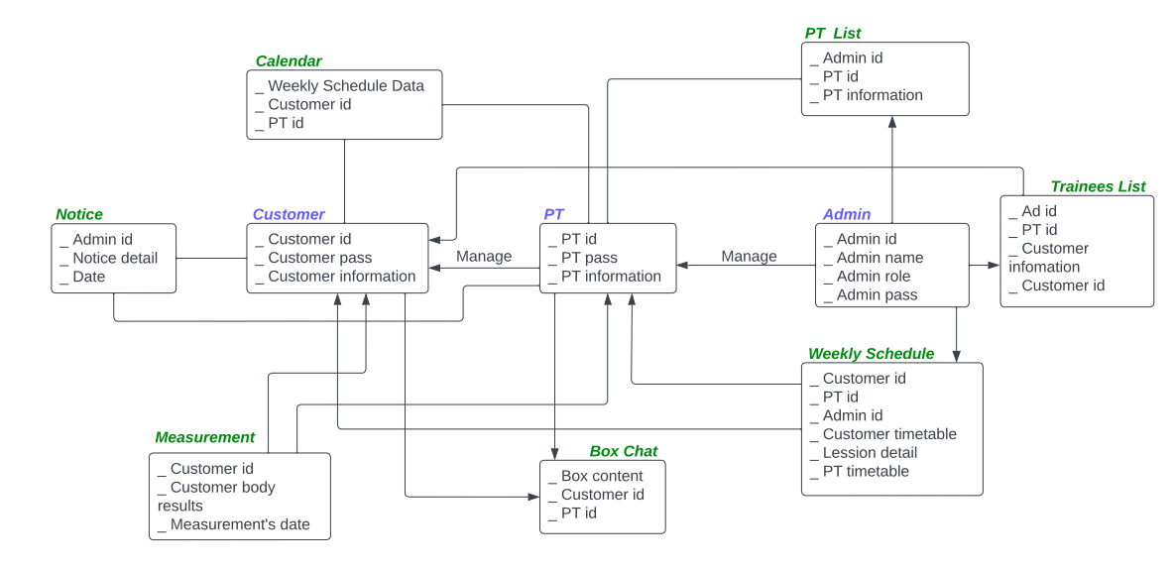

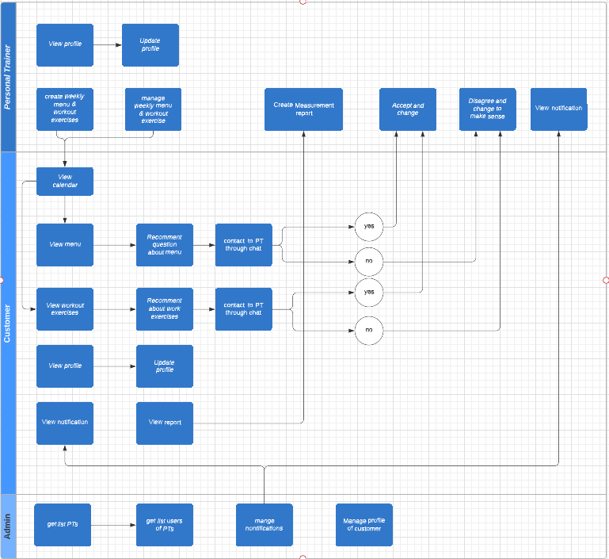

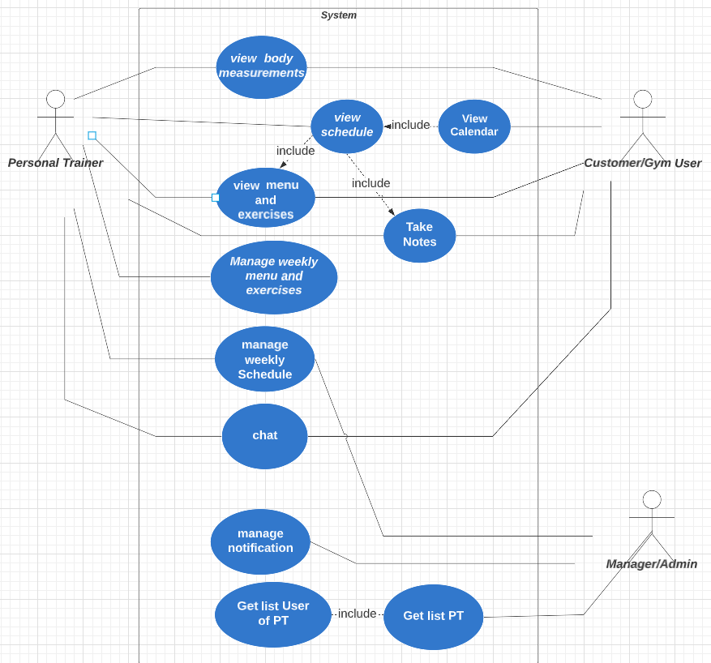

## **4.2** **Data Dictionary**

| **Data Element** | **Description** | **Composition or Data Type** | **Length** | **Values** |
| --- | --- | --- | --- | --- |
| username | the name that use to login (PT / Customer) | string | 3-16 |  |
| password | user’s password to login to server (PT / Customer) | string | 8-24 |  |
| name | name of user use to create account (PT / Customer) | character | 24 |  |
| email | email address of the customer who book a service (PT / Customer) | string |  |  |
| phone | telephone number of the customer use our service (PT / Customer) | integer | 10 |  |
| Service details | Which contained customer id and description about their service’s register | + customer’s id  + customer’s name  + service price  + register/expired date  + training centre location |  |  |
| Customer information | Which contained customer id and description about their service’s options and their own PT | + customer’s id  + customer’s name  + customer’s service details  + PT’s name |  |  |
| PT information | Which contained information of PT when they work in gym centre | + PT’s id  + PT’s name  + PT’s age  + PT’s timekeeping  + PT’s salary | String, integer, price |  |
| Timetable - Customer | The list of lessons of customer in a week | + customer’s id  + weekly practice lessons  + nutrition for trainees  + Attendance report |  |  |
| Timetable - PT | The schedule of PT in a week | + PT’s id  + weekly schedule  + Time |  |  |
| Announcement | Notice for PT and Customer | + Notice content  + menu, exercises, schedule change notice |  |  |
| Payment amount | Total price of an service in dollars and cents, calculated per service and costs incurred | Numeric, dollars and cents | dddd.ccc |  |
| Payment method | How the Customer paying | alphabelic | 16 | Payroll deduction,cash, credit card, debit card |

## 

## **4.3** **Reports**

| Report ID: | PTCSS -RPT-1 |
| --- | --- |
| Report Title: | Service and Quality |
| Report Purpose: | Customers complain that they can not feel better after using Gym’s service. |
| Priority: | Medium |
| Report Users: | Customer |
| Data Sources: | Database of previously placed service |
| Frequency and Disposition; | Report is generated on demand by a Customer. Data in the report is static. Report is displayed on the user's web browser screen on a computer, tablet, or smartphone. It can be printed if the display device permits printing. |
| Latency: | Complete report must be displayed to Customerwithin 3 seconds after it is requested. |
| Visual Layout: | Landscape mode |
| Header and Footer: | Report header shall contain the report title, Customer’s name, and date range specified. If printed, the report footer shall show the page number. |
| Report Body: | Fields shown and column headings:   * Customer’s ID * Register Date * Service ordered( listed booking time, service’s prices in the order) * PT Detail (Who is Customer’s trainer ) * Tax * Total price = Service’s price + Taxes   Selection Criteria: date range specified by Customer, inclusive of end points  Sort Criteria: reverse chronological order |
| End-of-Report Indicator: | None |
| Interactivity: | None |
| Security Access Restrictions: | A Customermay retrieve only his own service order history |

*[Note: Other* PTCSS *reports are not provided in this example.]*

## **4.4** **Data Integrity, Retention, and Disposal**

DI-1: The PTCSS shall retain Individual Customer service and information following the service’s booking date.

DI-2: The PTCSS shall save the result of the customer after measurement.

DI-3: Customer/PT information must be highly protected.

DI-4: Attendance will not be deleted until end of year.

DI-5: Box chat shall be privatised between PT and Customer.

# **5.** **External Interface Requirements**

## **5.1** **User Interfaces**

**UI-1**: The app shall permit complete navigation, exercises selection, food item selection by using the touch and touch keyboard.

**UI-2**: The app interface’s colour shall be bright and friendly with instruction in every page.

**UI-3**: The app’s notification shall be shown yellow with menu and exercises changes notifications, red with important notifications and blue with other notifications.

## **5.2** **Software Interfaces**

**SI-1**: PT and Customer Support System

**SI-1.1**: the PTCSS shall transmit the workout schedule and menu from PT role to Customer role in view mode.

**SI-1-2**: Admin role shall update the information of active customers to open Customer role for app access.

**SI-1.1**: the PTCSS shall transmit the gym’s schedule notification from Admin role to Customer role and PT role in notification box in view mode.

**5.3** **Hardware Interfaces**

No hardware interfaces have been identified.

## **5.4** **Communications Interfaces**

**CI-1:** The PTCSS app shall allow administrators to send notifications to users to inform them of any changes to gym activities

**CI-2:** The PTCSS app shall send alert notifications of unread chat messages between users and Personal Trainers.

**CI-3:** Within the chat function between users and PTs, users shall be able to send messages that contain text and images as well as attach files to those messages.

**CI-4:** Within the chat function between users and PTs, users shall not be able to attach images or files that exceed 25MB in size.

# **6.** **Quality Attributes**

## **6.1** **Usability Requirements**

**USAGE-1**: 95% of new customers can view and comment with menus and personal workout exercises without any errors.

**USAGE-2**: 95% of new PTs can manage and work with menus and workout exercises without any errors.

**USAGE-3**: 95% of new admins can manage and work with notifications without any errors.

## **6.2** **Performance Requirements**

**PER-1**: The system will hold a total of 200 users and up to 50 concurrent users during peak usage periods of 18:00 A.M. until 22:00 a.m. local time, with an estimated average session duration of 8 minutes.

**PER-2**: 95% of web pages will download completely within 4 seconds from the moment a user requests the page over a 20 Mbps or faster Internet connection.

**PER-3**: The system will display a confirmation message to the user within 3 seconds on average and up to 6 seconds after the user submits the information to the system.

## **6.3** **Security Requirements**

**SEC-1:** All network transactions involving personally identifiable information will be encrypted.

**SEC-2**: Users must log in to the system for all operations except viewing notifications.

**SEC-2**: Only admins manage notifications and work with notifications.

**SEC-4**: Only authorised menu and workout exercise administrators are allowed to work with menus and workout exercises.

**SEC-5**: The system will allow Patrons to only view the menu and their personal workout exercise, and can suggest ideas through comments.

## **6.4** **Safety Requirements**

**SAF-1**: The consumer may view any menu item in detail, including meals that have components that are underlined and are known to cause allergies in more than 5% of Vietnamese people.

**6.5** **Availability Requirements**

**AVL-1**: The solution will be accessible for standard usage and system maintenance tasks from 4:00 to 2:00 am every day of the week, including all gym holidays and the Vietnamese public holidays.

**AVL-2**: A day before the start of each new training week, the edit and post schedule and menu functions will not be accessible to personal trainers.

## **6.6** **Robustness Requirements**

**ROB-1**: If the connection happened when the personal trainers finished or issued a new schedule or menu. The technology enables a trainer to restore a partially completed